Bank Loan Report | Query Document
- Bank Loan Report Summary
KPI’S
Total Loan Application
SELECT COUNT(id) As Total_Loan_application FROM Bank_Loan_Data
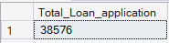
MTD Total Loan
SELECT COUNT(id) As MTD_Total_Loan_application FROM Bank_Loan_Data
Where MONTH(issue_date) = 12 AND YEAR(issue_date) = 2021
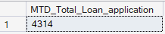
PMTD Total Loan
SELECT COUNT(id) As PMTD_Total_Loan_application FROM Bank_Loan_Data
Where MONTH(issue_date) = 11 AND YEAR(issue_date) = 2021
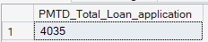

Total Funded Amount
SELECT SUM(loan_amount) As Total_Funded_Amount FROM Bank_Loan_Data
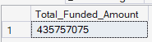
MTD Total Funded Amount
SELECT SUM(loan_amount) As MTD_Total_Funded_Amount FROM Bank_Loan_Data
Where MONTH(issue_date) = 12 AND YEAR(issue_date) = 2021
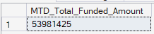
PMTD Total Loan
SELECT SUM(loan_amount) As PMTD_Total_Funded_Amount FROM Bank_Loan_Data
Where MONTH(issue_date) = 11 AND YEAR(issue_date) = 2021
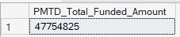
Total Amount Received
SELECT SUM(total_payment) As Total_Payment_Amount FROM Bank_Loan_Data
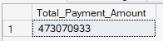
MTD Total Amount Received
SELECT SUM(total_payment) As MTD_Total_Payment_Amount FROM Bank_Loan_Data
Where MONTH(issue_date) = 12 AND YEAR(issue_date) = 2021
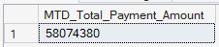
PMTD Total Amount Received
SELECT SUM(total_payment) As PMTD_Total_Payment_Amount FROM Bank_Loan_Data
Where MONTH(issue_date) = 11 AND YEAR(issue_date) = 2021
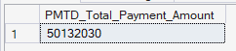

Average Interest Rate
SELECT ROUND(AVG(int_rate),4)*100 As Avg_Interest_Rate FROM Bank_Loan_Data
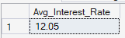
MTD Average Interest Rate
SELECT ROUND(AVG(int_rate),4)*100 As MTD_Avg_Interest_Rate FROM Bank_Loan_Data
Where MONTH(issue_date) = 12 AND YEAR(issue_date) = 2021
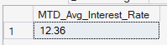
PMTD Average Interest Rate
SELECT ROUND(AVG(int_rate),4)*100 As PMTD_Avg_Interest_Rate FROM Bank_Loan_Data
Where MONTH(issue_date) = 11 AND YEAR(issue_date) = 2021
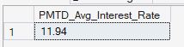

Average Debt-to-income Ratio (DTI)
SELECT ROUND(AVG(dti),4)*100 As Avg_dti_Ratio FROM Bank_Loan_Data
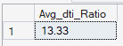

MTD Average Debt-to-income Ratio (DTI)
SELECT ROUND(AVG(dti),4)*100 As MTD_Avg_dti_Ratio FROM Bank_Loan_Data
Where MONTH(issue_date) = 12 AND YEAR(issue_date) = 2021
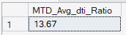
PMTD Average Debt-to-income Ratio (DTI)
SELECT ROUND(AVG(dti),4)*100 As PMTD_Avg_dti_Ratio FROM Bank_Loan_Data
Where MONTH(issue_date) = 11 AND YEAR(issue_date) = 2021
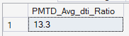

- Dashboard 1
GOOD LOAN ISSUED
Good Loan Percentage
SELECT
(COUNT(CASE WHEN loan_Status = 'fully Paid' OR loan_Status = 'Current' THEN id END)*100)
/
COUNT(id) AS Good_Loan_percentage
FROM Bank_Loan_Data
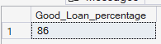
Good Loan Application
SELECT COUNT(id) AS Good_Loan_Application FROM Bank_Loan_Data
WHERE loan_status = 'Fully Paid' OR loan_status = 'Current'
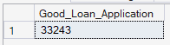
Good Loan Funded Amount Application
SELECT SUM(loan_amount) AS Good_Loan_Funded_Amount FROM Bank_Loan_Data
WHERE loan_status = 'Fully Paid' OR loan_status = 'Current'
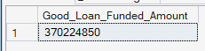
Good Loan Total Received Amount
SELECT SUM(total_payment) AS Good_Loan_toal_Amount FROM Bank_Loan_Data
WHERE loan_status = 'Fully Paid' OR loan_status = 'Current'
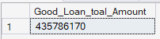

BAD LOAN ISSUED
Bad Loan Percentage
SELECT
COUNT(CASE WHEN loan_Status = 'Charged off' THEN id END)*100
/
COUNT(id) AS Bad_Loan_percentage
FROM Bank_Loan_Data
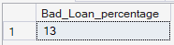
Bad Loan Application
SELECT COUNT(id) AS Bad_Loan_Application FROM Bank_Loan_Data
WHERE loan_status = 'Charged off'
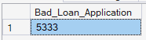
Bad Loan Funded Amount Application
SELECT SUM(loan_amount) AS Bad_Loan_Funded_Amount FROM Bank_Loan_Data
WHERE loan_status = 'Charged off'
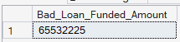
Bad Loan Total Received Amount
SELECT SUM(total_payment) AS Bad_Loan_toal_Amount FROM Bank_Loan_Data
WHERE loan_status = 'Charged off'
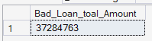

LOAN STATUS
SELECT
loan_status,
COUNT(id) AS LoanCount,
SUM(total_payment) AS Total_Amount_Received,
SUM(loan_amount) AS Total_Funded_Amount,
AVG(int_rate)*100 AS Intrest_Rate,
AVG(dti)*100 AS DTI
FROM
Bank_Loan_Data
GROUP BY
loan_status
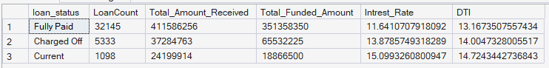

- Dashboard 2
Monthly Trends by Issue Date
SELECT
MONTH(issue_date) AS Month_Number,
DATENAME(MONTH,issue_date) AS Month_Name,
COUNT(id) AS Total_Loan_Application,
SUM(loan_amount) AS Total_Funded_Amount,
SUM(total_payment) AS Total_Received_Amount
FROM Bank_Loan_Data
GROUP BY MONTH(issue_date),DATENAME(MONTH,issue_date)
ORDER BY MONTH(issue_date)
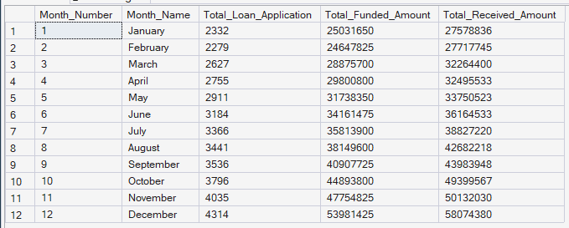

Regional Analysis by State
SELECT
address_state,
COUNT(id) AS Total_Loan_Application,
SUM(loan_amount) AS Total_Funded_Amount,
SUM(total_payment) AS Total_Received_Amount
FROM Bank_Loan_Data
GROUP BY address_state
ORDER BY address_state
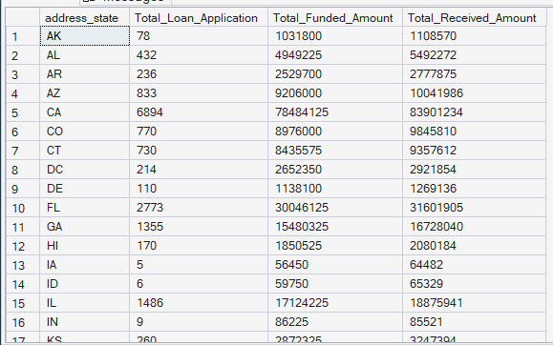

Loan Term Analysis (Donut Chart)
SELECT
term,
COUNT(id) AS Total_Loan_Application,
SUM(loan_amount) AS Total_Funded_Amount,
SUM(total_payment) AS Total_Received_Amount
FROM Bank_Loan_Data
GROUP BY term
ORDER BY term
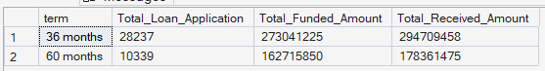

Employee Length Analysis (Bar Chart)
SELECT
emp_length,
COUNT(id) AS Total_Loan_Application,
SUM(loan_amount) AS Total_Funded_Amount,
SUM(total_payment) AS Total_Received_Amount
FROM Bank_Loan_Data
GROUP BY emp_length
ORDER BY emp_length
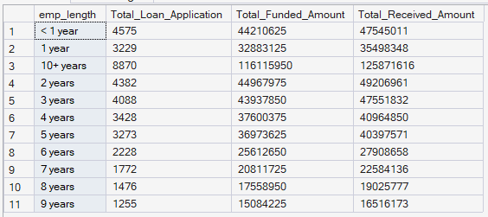

Loan Purpose Breakdown (Bar Chart)
SELECT
purpose,
COUNT(id) AS Total_Loan_Application,
SUM(loan_amount) AS Total_Funded_Amount,
SUM(total_payment) AS Total_Received_Amount
FROM Bank_Loan_Data
GROUP BY purpose
ORDER BY purpose
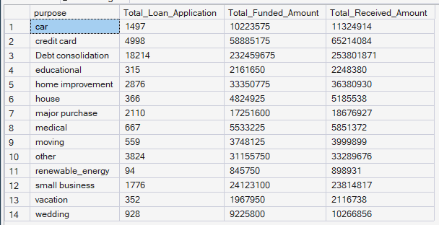

Home Ownership Analysis (Tree Map)
SELECT
home_ownership,
COUNT(id) AS Total_Loan_Application,
SUM(loan_amount) AS Total_Funded_Amount,
SUM(total_payment) AS Total_Received_Amount
FROM Bank_Loan_Data
GROUP BY home_ownership
ORDER BY COUNT(id) DESC
